**DAILY ONLINE ACTIVITIES SUMMARY**

|  |  |  |  |  |  |  |  |  |
| --- | --- | --- | --- | --- | --- | --- | --- | --- |
| **Date:** | **05/06/2020** | | | | | **Name:** | **Spoorthi M S** | |
| **Sem & Sec** | **6th /B** | | | | | **USN:** | **4AL17CS097** | |
| **Online Test Summary** | | | | | | | | |
| **Subject** | | **OR IA Test - 3** | | | | | | |
| **Max. Marks** | | **30** | | **Score** | | | **30** | |
| **Certification Course Summary** | | | | | | | | |
| **Course** | **Web Development** | | | | | | | |
| **Certificate Provider** | | | **Shaw Academy** | | **Duration** | | | **4weeks** |
| **Coding Challenges** | | | | | | | | |
| **Problem Statement:**  1.Python Program to Map Two Lists into a Dictionary Steps: Get n rollnos through keyboard and put it in list L and respective test marks in list M. Write the program takes two lists and maps two lists into a dictionary D.  2.Python Program to Take in the Marks of 5 Subjects and Display the Grade using if ... elif construct without using and operator for finding the range. | | | | | | | | |
| **Status: Completed** | | | | | | | | |
| **Uploaded the report in GitHub** | | | | | **Yes** | | | |
| **If yes Repository name** | | | | | <https://github.com/msspoorthi/onlinecoding> | | | |
| **Uploaded the report in slack** | | | | | **Yes** | | | |

**Online Test Details**

OR IA Test 3 Details:

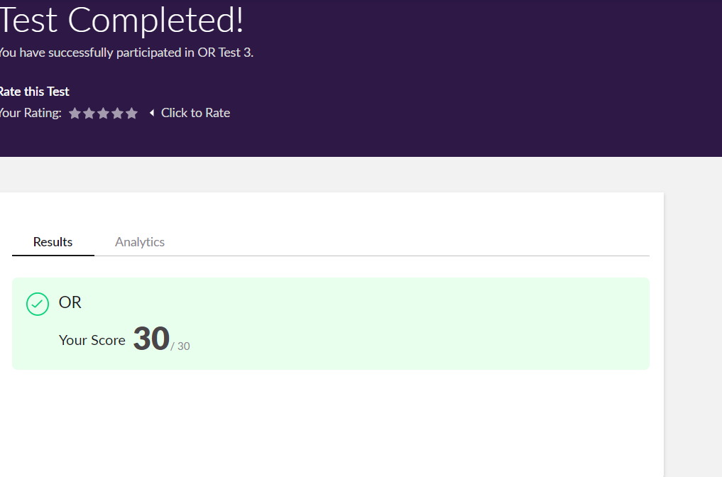

**Online Certification Details**

**Lesson**

* Programming Fundamentals
* PHP & Backend Code

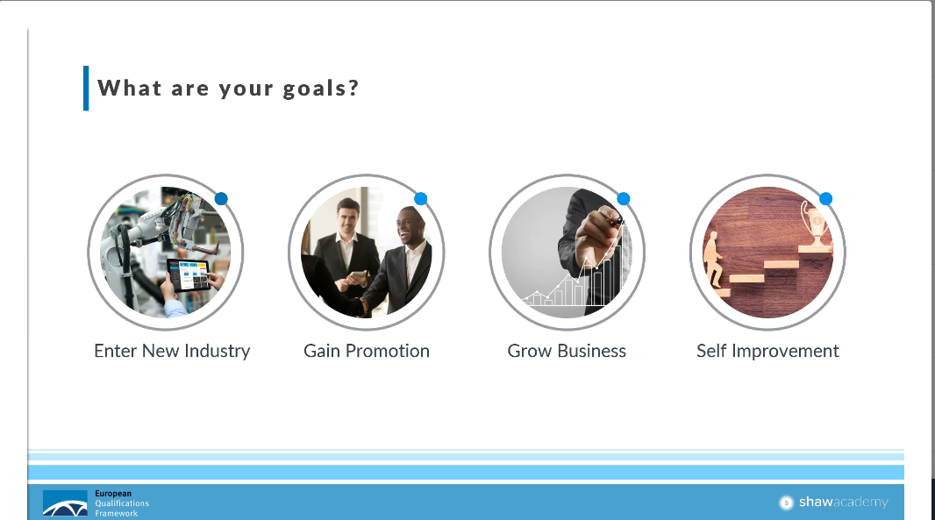

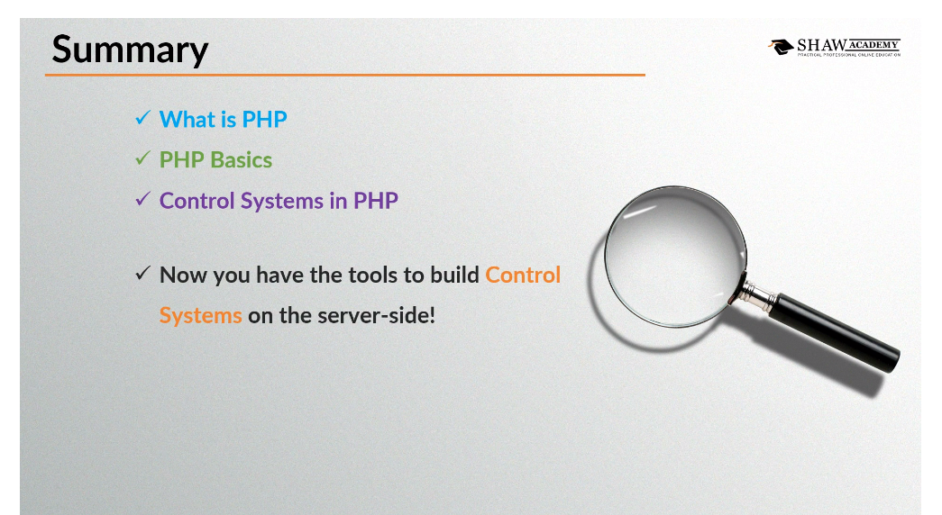

**Coding Challenge Details**

1. Python Program to Map Two Lists into a Dictionary Steps: Get n rollnos through keyboard and put it in list L and respective test marks in list M. Write the program takes two lists and maps two lists into a dictionary D.

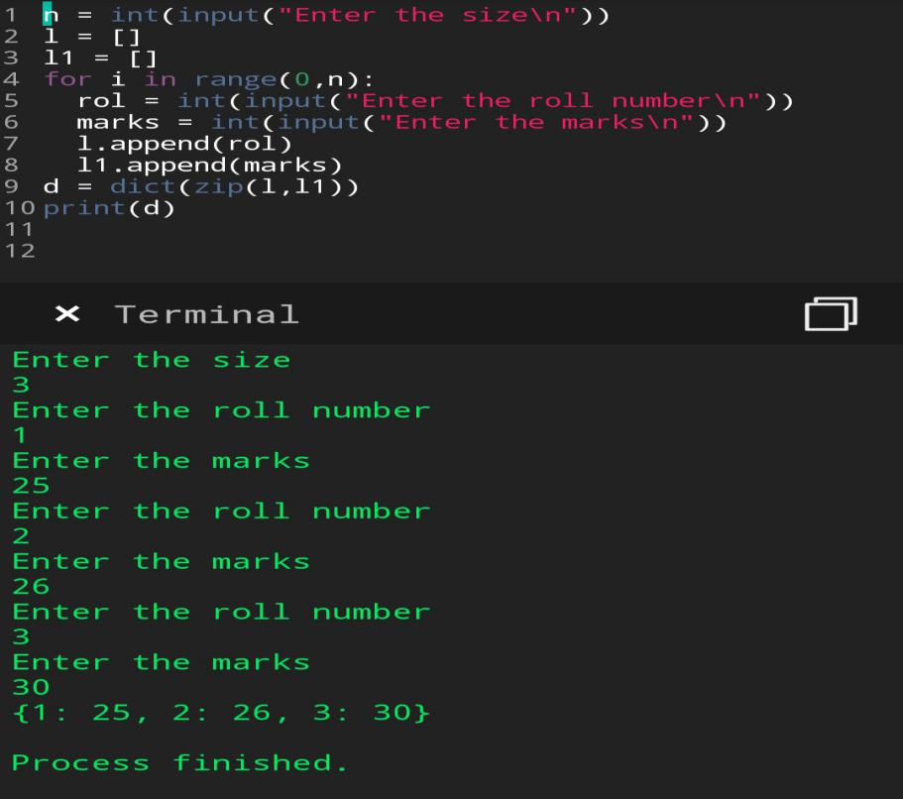

2.Python Program to Take in the Marks of 5 Subjects and Display the Grade using if ... elif construct without using and operator for finding the range.

